**5MP 15~50MM Global Shutter Camera Module**

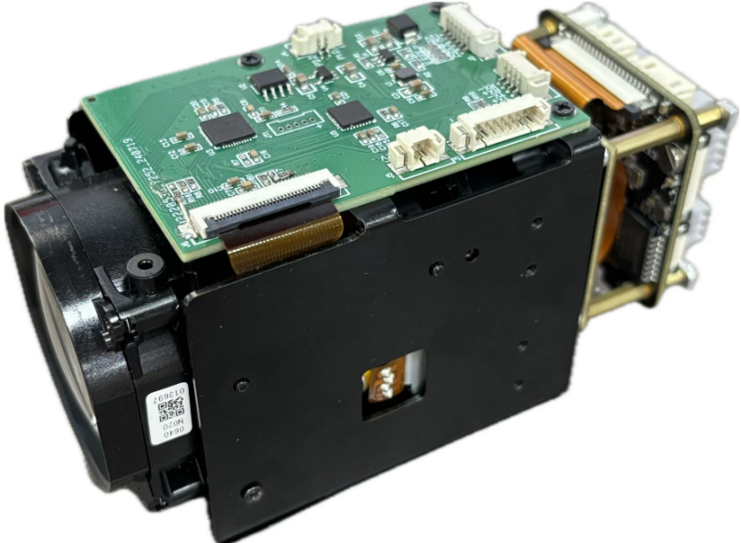

* Video Encoding:H.265/H.264/MJPEG
* Video resolution:2448*2048;
* Global shutter max to 5MP/60FPS
* Integrated neural network acceleration engine, computing power up to 2.5Tops INT8
* Dual ARM Cortex A55@1.2GHz processor, 32KB I-Cache, 32KB D-Cache ,256KB L3 cache
* USB3.0 video output,standard yuv protocol
* DC auto iris and CVBS can be optional ,need add one more expand board
* Default dual stream , main stream and sub stream
* Support AI super noise reduction, 3D noise reduction, 2D noise reduction, image edge enhancement, defogging, dynamic contrast enhancement, etc.
* Support automatic restart function after power failure/accidental failure;

**Datasheet:**

|  |  |  |  |
| --- | --- | --- | --- |
| Order Model:M568H19D_L21_10X | | | |
| System | | | |
| CPU Model | HI3519DV500 Dual ARM Cortex A55@1000MHz | | |
| CPU Ability | 2.5 Tops INT8 | | |
| Flash | 256Mbit SPI Nor Flash | | |
| DDR | 8Gbit DDR4 (2x 4Gbit) | | |
| Image | | | |
| Sensor Board | SONY IMX568 1/1.8″Global Shutter Sensor | | |
| Video Resolution | 2488*2048 /5MP | | |
| Video Compression | H.265/H.264/MJPEG | | |
| Video Frame | Main stream:2488*2048/2048*1520/ 1920*1080 1-60fps  Sub stream: 1280*720 /704*576/ 640*480 352*288 1-60fps | | |
| Lens | 15~50MM(Japan TAMRON brand) | | |
| Aperture | F1.4～F1.6 | | |
| Field angle |  | Wide | Tele |
| H | 26.3° | 8.1° |
| V | 20° | 6.2° |
| S/N Ratio | ≥52dB | | |
| 3D Noise | Support | | |
| Optical zoom | 4X | | |
| ICR Switch | Auto ICR full color switch to B/W | | |
| T-WDR | 120dB | | |
| BLC | Support | | |
| Focus control | Auto /Manual | | |
| Electronic shutter | 1/25—1/10000s | | |
| Min Illumination | Color 0.001 Lux@F1.6 | | |
| Audio | | | |
| Audio Interface | 2ch audio in(1ch Line In &1ch MIC In)  1ch audio out,support voice intercom | | |
| Audio compression | G.711A、G.711U | | |
| Image | | | |
| AE | support | | |
| AGC | Support | | |
| AWB | Support | | |
| 3D | Support | | |
| Privacy Mask | Up to set 4 Privacy mask area | | |
| Interesting area code | Support | | |
| Off network record video | Support | | |
| Motion detect | Up to set 4 motion detect area | | |
| Day&Night Switch | Built-in intelligent algorithm to auto control IR CUT switch,color and white&night auto switch | | |
| Video adjust | Adjustable image contrast, brightness, saturation, sharpness and image mirroring, flipping, fog penetration, strong light suppression, backlight compensation, noise reduction level, digital wide dynamic, etc. | | |
| Corridor mode | support | | |
| Remote manager | System setting/Video stream management/Account management/Network management | | |
| Alarm Detect | E-mail alarm,PC client alarm,Motion detect alarm | | |
| Function Interface | 1CH Reset | | |
| 1CH RS485(Optional) | | |
| 1CH alarm in(standard),1CH alarm out（optional,need add one board） | | |
| SD/TF card storage，max 1T storage（optional,need add one board） | | |
| OSD | OSD place ,color ,words can be config | | |
| Network | | | |
| Ethernet Interface | 1PCS RJ45 100M | | |
| Protocol | TCP/IP、UDP、RTP、RTSP、RTCP、RTMP、HTTP、DNS、DDNS、DHCP、NTP、PPPOE、SMTP、UPNP; | | |
| ONVIF | ONVIF Profile S | | |
| General Info. | | | |
| Power Supply | DC12V(±10%) | | |
| Power Consumption | TBD | | |
| Working temperature | -30°~+70° | | |
| Working humidity | 10%~90% | | |

Pin definition :

1.AF Board (Zoom/Focus/PTZ)

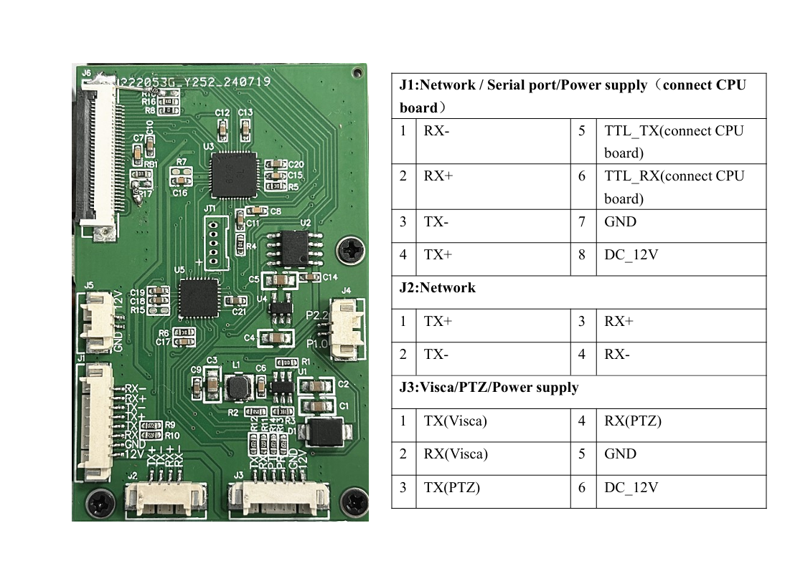

2.IPC camera （sensor+cpu board）

